
POSTS AND TELECOMMUNICATIONS INSTITUTE OF TECHNOLOGY
FACULTY OF INFORMATION TECHNOLOGY 1


MAJOR ASSIGNMENT
ANALYSIS AND DESIGN OF INFORMATION SYSTEMS
SUBJECT NO. 32

Class: | E22HTTT
Author: | Đỗ Trung Quân
ID: | B22DCAT233
Mentor: | Đỗ Thị Bích Ngọc

Hà Nội - 2025
Subject No. 32

Duration: 90 minutes

An online department store management system could be used by management staff, sale staff, and customer:

● Management staff: view all kinds of statistics: imports, exports, customers and suppliers. Commodity information management. Import goods from suppliers, manage supplier information
● Sale staff: browse invoices online, pack and deliver to delivery staff
● Customer: register as a member, find and look up product information, order online, track invoice status.

Considering two modules and answering questions
● Customer registers as a member: selects the member registration menu → enters customer information, clicks add → the system saves to the database.
● Management staff imports goods from suppliers: selects the import menu → find suppliers by name (if not, add a new one) → Repeats the following steps for all imported goods: selects search for items by name (if not already available, then add new) → enters quantity + unit price → repeats until all the imported goods are finished, then submits → prints out the invoice
Table of Contents
I. CONCEPT EXPLORATION 4
II. BUSINESS MODEL 11
A. By natural language 11
1. Objective and scope 11
2. Detailed business process of functions 12
3. Information about related objects 13
4. Relationships among objects 13
B. By UML 14
1. General use case diagram 14
2. Detail use case diagrams: 15
C. By analysis 17
1. Scenario 17
2. Entity class extraction 23
3. Classes diagram 27
4. State diagram 31
5. Communication diagram & sequence diagram 33
D. By design 38
1. Design of entity classes 38
2. Database design 40
3. Detail design for modules 43
4. Deployment design 54
E. By programming 56
1. UI 56
2. Files structure 62
3. Source code 62

I. CONCEPT EXPLORATION
GLOSSARY LIST

No. | Vietnamese | English |  | Meanings
Category 1: related to human
1 | Nhân viên quản lý | Management staff | Personnel responsible for overseeing and analyzing operational data including statistics on imports, exports, customer metrics, supplier performance, as well as managing product information in the online department store system
2 | Nhân viên bán hàng | Sale staff | Employees who handle sales operations such as reviewing and processing invoices online, preparing and packing orders for shipment, and coordinating with delivery staff to ensure timely dispatch to customers
3 | Khách hàng | Customer | An individual or entity that engages with the online department store to browse, select, and purchase products or services, often tracking their orders and providing feedback through the system
4 | Nhà cung cấp | Supplier | A business entity or individual that supplies goods to the department store
5 | Nhân viên giao hàng | Delivery staff | Personnel tasked with transporting packaged orders from the store's warehouse or fulfillment center to the customer's specified address, ensuring safe and timely delivery while updating order status in the system
6 | Thành viên | Member | A customer who has registered an account in the system, gaining access to benefits such as personalized recommendations, order history tracking, exclusive discounts, and streamlined purchasing processes
7 | Người dùng | User | An individual who interacts with the online department store system through an user account, thus have access to features corresponding to his/her role.
Category 2: related to object
8 | Mặt hàng | Product | A specific item or good available for sale in the department store, including details such as name, description, price, stock level, and specifications
9 | Hàng nhập | Import goods | Goods received and added into the store's inventory from suppliers, including quantities, costs, and associated documentation
10 | Hàng xuất | Export goods | Goods sold and removed from the store's inventory to fulfill customer orders, including details on quantities, values, and dispatch records
11 | Thống kê | Statistics | Compiled data and analytical reports on various operational aspects like inventory levels, sales trends, customer behavior, and supplier performance
12 | Thống kê hàng xuất | Exports statistics | Detailed reports and metrics on goods sold and dispatched to customers, including sales volumes, revenue generated, and time-based trends
13 | Thống kê hàng nhập | Imports statistics | Detailed reports and metrics on goods received from suppliers, including purchase volumes, costs incurred, and supplier efficiency analysis
14 | Thống kê người dùng | Customer statistics | Data analysis on customer-related metrics such as demographics, purchase history, frequency of visits, average spend, and loyalty patterns
15 | Thống kê nhà cung cấp | Supplier statistics | Data on supplier performance including delivery timeliness, quality ratings, transaction volumes, and cost-effectiveness evaluations
16 | Hóa đơn | Invoice | A formal document itemizing a sales transaction, detailing products purchased, quantities, unit prices, taxes, discounts, and total amount payable
17 | Gói hàng | Package | A securely wrapped and labeled bundle of products prepared for safe transportation and delivery to the customer
18 | Tài khoản | Account | A secure user profile in the system storing personal information, login credentials, order history, and preferences for personalized access
19 | Giỏ hàng | Shopping cart | A temporary virtual container where customers add and manage products they intend to purchase before proceeding to checkout
20 | Mã giảm giá | Voucher | A promotional instrument, such as a code or coupon, that entitles the holder to discounts, rebates, or special offers on purchases
21 | Lượt đánh giá | Reviews | Customer-provided feedback, ratings, and comments on products or services, used to inform other potential buyers and improve store offerings
22 | Đơn giá | Unit price | The cost assigned to a single unit of a product, excluding any bulk discounts or additional fees
23 | Số lượng | Quantity | The numerical count of product units in inventory, an order, or a transaction, used for stock management and order fulfillment
24 | Tổng tiền | Total | The aggregate sum of all costs in a transaction, including product prices, quantities, taxes, shipping fees, and any applied discounts
Category 3: related to activities
25 | Đăng nhập | Login | The secure process of authenticating and gaining access to the system using username and password or other credentials
26 | Đăng ký | Register | The activity of creating a new member account by providing personal details, verifying identity, and agreeing to terms for system usage
27 | Nhập hàng | Import | The operational process of receiving, inspecting, and recording goods from suppliers into the inventory system, updating stock levels accordingly
28 | Xuất hàng | Export | The process of selecting, removing, and dispatching sold goods from inventory to customers, updating records for sales and stock reduction
29 | Đổi mật khẩu | Change password | The security activity of updating the account's login password to maintain data protection and prevent unauthorized access
30 | Cập nhật thông tin cá nhân | Update personal information | The process of modifying and saving changes to a user's account details such as name, address, contact information, or preferences
31 | Xem thống kê | View statistics | The action of accessing and reviewing detailed operational reports and data visualizations on imports, exports, customers, and suppliers
32 | Quản lý thông tin hàng hóa | Manage commodity information | The administrative tasks of adding, editing, or deleting product details in the system, including descriptions, prices, and availability
33 | Quản lý thông tin nhà cung cấp | Manage supplier information | The tasks of maintaining and updating supplier records, including contact details, contracts, performance history, and integration with inventory
34 | Duyệt hóa đơn trực tuyến | Browse invoice online | The online activity of viewing, searching, and examining invoice details for verification, processing, or record-keeping purposes
35 | Đóng gói hàng | Pack | The preparation step of securely wrapping, boxing, and labeling products to ensure safe handling during delivery
36 | Vận chuyển | Deliver | The logistics activity of transporting packaged orders from the store or warehouse to the customer's specified location
37 | Tìm mặt hàng | Search product | The user action of querying the system database to locate and retrieve information on specific products based on keywords, categories, or filters
38 | Đặt hàng trực tuyến | Order online | The customer process of selecting products, adding to cart, providing payment and delivery details, and submitting a purchase request via the web platform
39 | Theo dõi trạng thái đơn hàng | Track invoice status | The monitoring activity where users check the real-time progress of an order, from confirmation to shipment and delivery completion

II. BUSINESS MODEL

A. By natural language

1. Objective and scope
* Objective: This is a web application that aims to streamline the management of an online department store including supporting management staff in overseeing operations, sales staff in handling orders, and customers in purchasing.
* Scope:
- Type of application: web application
- Users and their corresponding granted functions: only the department store’s staff (Management staff, sale staff) and the customer could use this application.
- Management staff:
  - View all kinds of statistics: imports, exports, customers and suppliers.
  - Manage commodity information, supplier information.
  - Import goods from suppliers.
- Sale staff:
  - browse invoices online and set up the export procedures before delivery.
- Customer:
  - login, register, update personal information as a member.
  - find and look up product information.
  - order online and track invoice status.

2. Detailed business process of functions
* Registers as a member:
- A customer selects the member registration menu → enters customer information, clicks add → the system saves to the database.
* Imports goods from suppliers:
- A management staff selects the import menu → find suppliers by name (if not, add a new one) → Repeats the following steps for all imported goods: selects search for items by name (if not already available, then add new) → enters quantity + unit price → repeats until all the imported goods are finished, then submits → prints out the invoice

3. Information about related objects
- User : full name, date of birth, gender, telephone, email, password.
- Customer: same as User, address
- Staff: same as User, role
- Management staff: same as Staff
- Sales staff: same as Staff
- Supplier: name, telephone, email, address
- Delivery staff: name, gender, date of birth, telephone
- Category: title, description
- Product: name, Category, quantity, unit price, description
- Invoice: order date, list of export Products, Customer, Delivery staff, Sales staff, status, total
- Import invoice: list of import Products, Supplier, Management staff, import date, total

4. Relationships among objects
- User - Customer: 1 - 1
- User - Staff: 1 - 1
- Staff - Management staff: 1 - 1
- Staff - Sales staff: 1 - 1
- Product - Category: N - 1
- Product - Invoice: N - N
- Product - Import invoice: N - N
- Invoice - Customer: N - 1
- Invoice - Sales staff: N - 1
- Invoice - Delivery staff: N - 1
- Import invoice - Supplier: N - 1
- Import invoice - Management staff: N - 1

B. By UML

1. General use case diagram
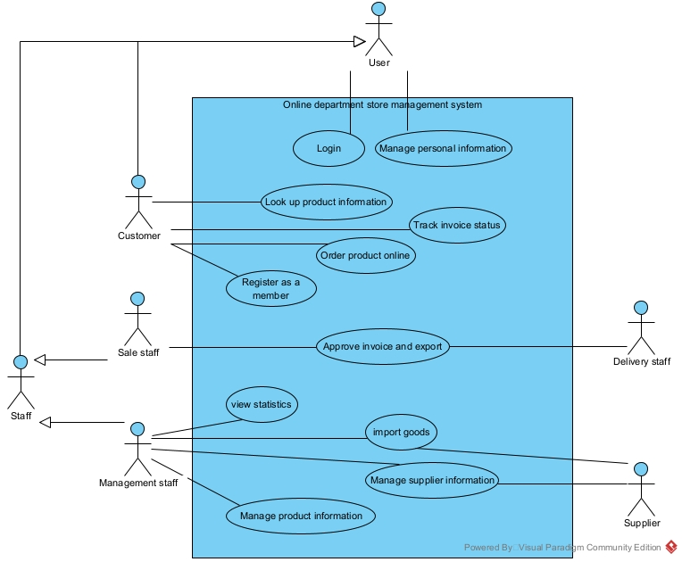
* Description of UC
- Login: this use case enables the customer, sale staff and management staff to authenticate and access the online department store management system using their credentials.
- Manage personal information: this use case enables the customer, sale staff and management staff to update and maintain their personal details such as name, address, and contact information within the system.
- Register as a member: this use case enables the customer to create a new member account by providing personal information
- Look up product information: this use case enables the customer to search and view detailed information about products available in the online department store.
- Track invoice status: this use case enables the customer to monitor the real-time progress of their orders from confirmation to delivery.
- Order product online: this use case enables the customer to select products, add them to the shopping cart, and complete the purchase process online.
- Approve invoice and export: this use case enables the sale staff to browse and approve invoices, followed by initiating the export process for order fulfillment.
- View statistics: this use case enables the management staff to access and analyze detailed reports on imports, exports, customers, and suppliers.
- Import goods: this use case enables the management staff to receive and record goods from suppliers into the inventory system.
- Manage supplier information: this use case enables the management staff to add, edit, or delete supplier details and maintain supplier records.
- Manage commodity information: this use case enables the management staff to add, edit, delete, or update information about products in the system.

2. Detail use case diagrams:
- Registers as a member module
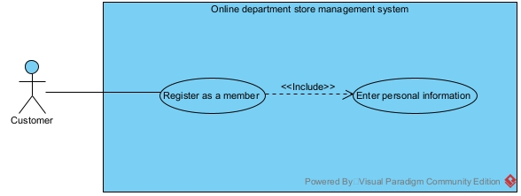
* Description of UC:
- Register as a member: this use case enables the customer to create a new member account in the online department store management system
- Enter personal information: this use case enables the customer to fill the required personal information in order to finish the registration process.
- Import goods module
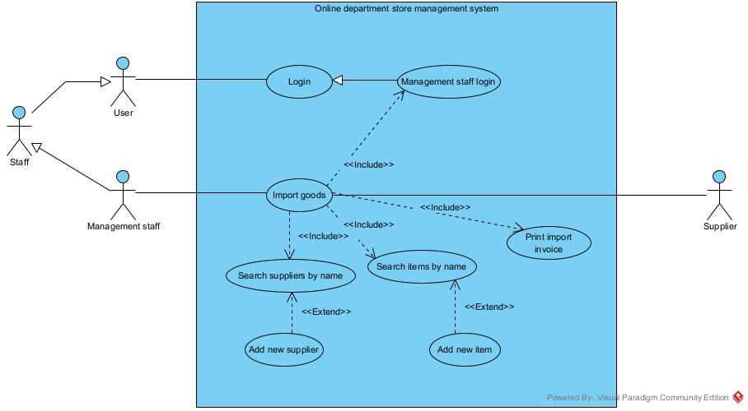

* Description of UC:
- Login: this use case enables the customer, sale staff and management staff to authenticate and access the online department store management system using their credentials.
- Management staff login: this use case enables the management staff to authenticate and access the online department store management system using their credentials.
- Import goods: this use case enables the management staff to receive and record goods from suppliers into the inventory system.
- Search suppliers by name: this use case enables the management staff to search for suppliers in the system by entering their name.
- Search items by name: this use case enables the management staff to search for items in the system by entering its name.
- Print import invoice: this use case enables the management staff to save and print the import invoice to complete the import process.
- Add new supplier: this use case enables the management staff to create and add a new supplier to the system.
- Add new item: this use case enables the management staff to create and add a new item to the system.

C. By analysis

1. Scenario
a. Registers as a member module
Scenario | Registers as a member
Actors | Customer
Pre conditions | Customer hasn’t had a member account yet
Post conditions | Customer successfully register a member account
Main events | - From the Greeting interface, a customer A select the register as a member function  - The system shows the register UI containing:  - some text fields to enter these following member information: full name, date of birth, address, email, telephone number, password  - a combobox to select gender  - a button “Add” to submit  - a button “Back”  - The customer fill all the required information and click “Add” button  - The system pops up a register successfully notification + navigates to the Greeting UI
Exceptions | 3. The customer enter the wrong syntax in 1 of these following text fields: email, telephone number, password; or trying to register with an existed account’s email/telephone number  3.1. The system pops up an error notification require the customer to try again  3.2. The customer fill the form with valid information + clicks Add

b. Import goods module
Scenario | Import goods
Actors | Management staff, supplier
Pre conditions | - The Management staff has already login using a Management staff account  - There is at least 1 supplier is required to supply goods at the moment
Post conditions | The management staff successfully import goods from suppliers
Main events | - After login, at the main management staff UI, a management staff A selects the import menu  - The system shows the Search supplier by name UI with:  - a text field to enter supplier name  - a Search button  - an Add button to add a new supplier  - a table to show searching result  - a button Back  - The management staff asks the supplier for his/her name and telephone number  - The supplier answer: name B, tel: 0902170359  - The management staff enter “B” in the search text field + click Search  - The system demonstrates the UI with the search result:  ID name telephone email address select  1 B 0902170359 quantrungdo198@gmail.com Kim Ngưu, HBT, HN ☐  2 B 0912345678 example@gmail.com Tran Phu, Hoan Kiem, HN ☐  Back  - The management staff selects first row as the corresponding supplier  - The system switches to the Search items by name UI containing:  - a text field to enter item name  - a Search button  - a Add button to add a new item  - a table to show searching result  - a table to show selected items  - a remove button  - 2 buttons Submit and Back  - The management staff asks the supplier for his/her item’s name  - The supplier answer: “Dien thoai A”  - The management staff enter “Dien thoai A” in the search text field + click Search  - The system demonstrate a list of all items whose name contains the keyword “Dien thoai A” as the search result:  Items table:  ID name Category Description Unit price select  1 Dien Thoai A smartphone 15.999.000 VND ☐  2 Dien Thoai A24 smartphone 19.999.000 VND ☐  - The management staff selects first row as the corresponding item  - The system updates the selected items table with “Dien thoai A” row and remove “Dien thoai A” row from the first table; the selected items table also provide an option to update the import quantity, import unit price and note of each selected item  Items table:  ID name Category Description Unit price select  2 Dien Thoai A24 smartphone 19.999.000 VND ☐  Selected items table:  ID name Category Import unit price quantity note Import price select  1 Dien Thoai A smartphone 0 1 0 ☐  Submit  - The management staff asks the supplier for the import quantity and import unit price of that item  - The supplier answer: “10”, “13.999.000 VND”  - The management staff select the “Dien thoai A” item in the second table and enter that information into the Import unit price cell and quantity cell.  - The system update the import quantity, import unit price and the import price of that item in the selected items table  Selected items table:  ID name Category Import unit price quantity note Import price select  1 Dien Thoai A smartphone 13999000 10 139.990.000 ☐  Submit  (Repeat steps 10-19 until all the imported goods are finished)  - The management staff click Submit button  - The system switches to the Print import invoice UI containing:  - information of supplier  - managementStaff name  - a table show the import item list  - detail information of invoice: date, total  - 2 buttons Print and Cancel  Import date: 16/11/2025  Management staff: Nguyễn Văn A  Supplier: B  Address: Kim Ngưu, HBT, HN  Telephone: 0902170359  Selected item list: (1 item)  ID name Category Import unit price quantity note Import price  1 Dien Thoai A smartphone 13.999.000 10 139.990.000  Print  - The management staff reviews the import invoice and clicks Print  - The system displays the import successfully alert, prints out the invoice and returns to the main UI of the management staff.  - The management staff tells the supplier the completion of import goods process
Exceptions | 7. There is no data about the supplier on the search result => Add a new supplier based on the scenario “Add new supplier” from the Add new supplier Usecase  13. There is no data about the item on the search result => Add a new item based on the scenario “Add new item” from the Add new item Usecase

*Add new supplier scenario
Scenario | Add new supplier
Actors | Management staff, supplier
Pre conditions | The Management staff doesn’t find the supplier’s data after search his/her name on the Search supplier by name UI during the import goods process
Post conditions | The supplier data is successfully added into the system
Main events | - The management staff click the Add button  - The system shows the Add new supplier UI containing:  - text fields of following required information: name, telephone, email, address  - a Add button  - a Back button  - the management staff asks the supplier his/her details information: name, telephone, email, address  - The supplier answer: “B; 0902170359; quantrungdo198@gmail.com; Kim Ngưu, HBT, HN”  - The management staff enter all of them and click Add  - The system popup a successful notification and return to the Search supplier by name UI
Exceptions | 5. The management staff enter the wrong syntax in 1 of these following text fields: email, telephone number; or trying to add supplier with an existed email/telephone number  5.1. The system pops up an error notification require the staff to try again  5.2. The management staff fill the form with valid information + clicks Add

*Add new item scenario
Scenario | Add new item
Actors | Management staff, supplier
Pre conditions | The Management staff doesn’t find the item’s data after search the item name on the Search item by name UI during the import goods process
Post conditions | The item data is successfully added into the system
Main events | - The management staff click the Add button  - The system shows the Add new item UI containing:  - text fields of following required information: name, category, description, unit price  - a Add button  - a Back button  - the management staff asks the supplier his/her item information: name, category, description (optional)  - The supplier answer: “Dien thoai A”, “smartphone”  - The management staff enter them and his favourite unit price + click Add  - The system popup a successful notification and return to the Search item by name UI
Exceptions | 5. The management staff trying to add item that already existed (duplicate item’s name and category)  5.1. The system pops up an error notification require the staff to try again  5.2. The management staff fill the form with valid information + clicks Add

2. Entity class extraction
Step 1: Describe the system within a paragraph
The system is a web application designed to manage the work flow of an online department store. For particular, management staff can login using their account, view all kinds of statistics: imports, exports, customers, suppliers; manage products information: name, category, quantity, unit price, description and suppliers information: name, telephone, email, address; import goods from suppliers and printout import invoice. Sale staff can login using their account; browse invoices online and view its detailed information: order date, total, items list, customer information, note, invoice status; update the status of exported invoice and deliver packed products to delivery staff. Customer can login, register, manage their personal account information: full name, date of birth, address, gender, telephone, email, password, role as a member; find and look up products information; order online and track invoice status.

Step 2: extract nouns appeared in the paragraph
- Nouns related to human: management staff, sale staff, delivery staff, customer, suppliers, member, staff.
- Nouns related to object: system, application, work flow, department store, account, invoice, goods, products, items, import invoice
- Nouns related to information: import statistics, export statistics, customer statistics, supplier statistics, information, name, category, quantity, unit price, import unit price, description, telephone, email, address, order date, total, items list, note, invoice status, full name, date of birth, gender, address, password, role.

Step 3: Evaluate and select nouns as entity classes or attributes
- Nouns related to human:
- user: a class User (abstract): full name, date of birth, gender, telephone, email, password, role.
- staff: a class Staff (abstract): role: inherits from User
- management staff: a class ManagementStaff: inherits from Staff
- sale staff: a class SaleStaff: inherits from Staff
- customer: a class Customer: inherits from User
- supplier: a class Supplier: name, telephone, email, address
- delivery staff: a class DeliveryStaff: name, gender, date of birth, telephone
- member = customer’s account: an abstract noun -> reject
- Nouns related to object
- system, application, work flow, department store: abstract nouns -> reject
- account: an abstract noun for user -> reject
- invoice: a class Invoice: order date, note, invoice status
- goods = item = product: a class Product: name, quantity, unit price, description
- import invoice: a class ImportInvoice: import date, note
- Nouns related to information:
- import statistics: a class ImportStats inherits from Product
- export statistics: a class ExportStats inherits from Product
- customer statistics: a class CustomerStats inherits from Customer
- supplier statistics: a class SupplierStats inherits from Supplier
- information: an abstract noun -> reject
- name: an attribute of Customer, Product, Supplier, ManagementStaff, DeliveryStaff
- telephone, gender, email, address, full name, date of birth, gender, password, role: attributes of User, some of them also belong to Supplier or DeliveryStaff
- address: attributes of Customer
- quantity, unit price, import unit price, description: attribute of Product
- category: a class Category: title, description
- order date, note, invoice status, total: attribute of Invoice
- item list: plural of Product

=> Collection of entities: ManagementStaff, SaleStaff, Customer, Supplier, DeliveryStaff, Staff, User, Invoice, Product, ImportInvoice, ImportStats, ExportStats, CustomerStats, SupplierStats, Category

Step 4: Determine the quantitative relationship between entities.
- Each Invoice can have multiple Products while a Product can belong to multiple Invoices. -> Invoice - Product is n-n
=> require a class ExportProduct to connect bettween 1 Invoice and 1 Product. This association relationship determines the quantity and note of each Product in a specific Invoice.
- Each Customer can have multiple Invoice while an Invoice only can belong to 1 Customer -> Customer - Invoice is 1-n
- Each Product can belongs to 1 Category while a Category can have multiple Products -> Product - Category is 1-n
- Each Invoice can only be delivered by a DeliveryStaff while a DeliveryStaff can delivery multiple Invoices -> Invoice - DeliveryStaff is n-1
- Each Invoice can be approved by only 1 SaleStaff while a SaleStaff can approves multiple Invoices -> Invoice - SaleStaff is n-1
- Each ImportInvoice can contains multiple Products while each Product can belong to multiple ImportInvoice -> ImportInvoice - Product is n-n
=> require a class ImportProduct to connect bettween 1 ImportInvoice and 1 Product. This association relationship determines the quantity, import unit price and note of each imported Product in a specific ImportInvoice.
- Each ImportInvoice can belong to 1 Supplier while each Supplier can have multiple ImportInvoice -> ImportInvoice - Supplier is n-1
- Each ImportInvoice can be created by 1 ManagementStaff while a ManagementStaff can created multiple ImportInvoice -> ImportInvoice - ManagementStaff is n-1

Step 5: Identify object relationships between entities.
- Customer is a component of Invoice
- Product is associated with Invoice to create an unique ExportProduct
- Category is a component of Product
- DeliveryStaff is a component of Invoice
- SaleStaff is a component of Invoice
- Product is associated with ImportInvoice to create an unique ImportProduct
- Supplier is a component of ImportInvoice
- ManagementStaff is a component of ImportInvoice
System entity class diagram:
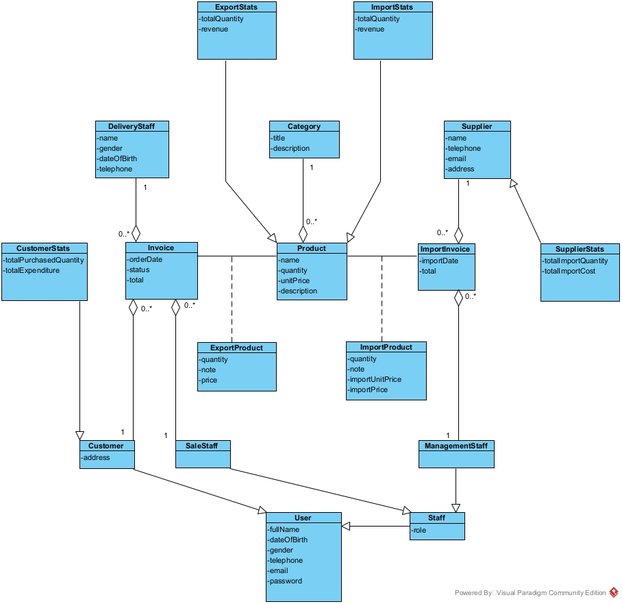

3. Classes diagram
Analysis the “Register as a member” module:
- At first, the Greeting UI of the system is showed -> need a class: GreetingView which has at least:
- Login button -> subLogin
- Register as a member button -> subRegister
- the customer chooses the register option -> the interface to register as a member appears-> need a class: RegisterView which has at least:
- some text fields to enter these following member information: full name, date of birth, email, telephone number, password, address -> inFullname, inDOB, inEmail, inTel, inPassword, inAddress
- a combobox to select gender -> inGender
- a button “Add” to submit -> subAdd
- a button “Back” -> subBack
- Fill the form and click on the Add button -> The system has to save the new member data into the system-> need a method: addCustomer()
- input: an object of Customer
- output: boolean
-> assign this method to the entity class: Customer
- After saving the new member data, the system navigates to the Greeting UI

Class diagram for “Register as a member” module:

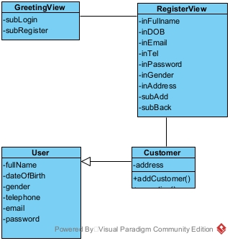

Analysis the “Import goods” module:
- After login, the main management staff UI is showed -> need a class: ManagementStaffHomeView which has at least:
- an option to choose the import goods feature -> subImport
- Logout button -> subLogout
- After the management staff chooses the import option -> the interface to search supplier by name appears -> need a class: SearchSupplierView which has at least:
- a text field to enter supplier name -> inSupplierName
- a Search button -> subSearch
- a Add button to add a new supplier -> subAdd
- a table to show list of found suppliers -> outsubSupplierList
- a Back button -> subBack
- Enter the name and click on the search button -> The system has to search all suppliers according to the given name-> need a method: searchSupplierByName()
- input: supplier name
- output: list of suppliers
- assign this method to the entity class: Supplier.
- The results are then displayed on the SearchSupplierView.
- In case the supplier is new and need to be added into the system, the staff chooses the Add button and the add supplier UI appeared -> need a class: AddSupplierView which has atleast:
- text fields of following required information: name, telephone, email, address -> inName, inTel, inEmail, inAddress
- a Add button -> subAdd
- a Back button -> subBack
- that needs a method to add new supplier into the system: addSupplier()
- input: an object of Supplier
- output: boolean
=> assign this method to the entity class: Supplier
- The management staff select the correct supplier and click Next -> the system redirects to the search item by name interface -> need a class: SearchItemView which has at least:
- a text field to enter item name -> inItemName
- a Search button -> subSearch
- a Add button to add a new item -> subAdd
- a table to show list of found items -> outsubItemList
- a table to show selected items -> inoutSelectedItemList
- 2 buttons Submit and Back -> subSubmit, subBack
- The management staff enter the item name and click Search -> the system has to return all items whose name containing the given keyword -> need a method: searchItemByName()
- input: item name
- output: list of product
=> assign this method to the entity class: Product
- The results are then displayed on the SearchItemView.
- In case the item is new and need to be added into the system, the staff chooses the Add button and the add item UI appeared -> need a class: AddItemView which has atleast:
- text fields of following required information: name, category, description, unit price -> inName, inCategory, inUnitPrice, inDescription
- a Add button -> subAdd
- a Back button -> subBack
- In order to have the list of all categories to display and let the user choose on the AddItemView -> needs a method to get all categories in the system: getCategory()
- input: none
- output: list of Category
=> assign this method to the entity class: Category
  - After filling item information and click Add, the new item is added into the system -> needs a method to add new item into the system: addItem()
- input: an object of Product
- output: boolean
=> assign this method to the entity class: Product
- The management staff select the correct item and update its import unit price and quantity in the selected items table + click Submit -> the system redirects to the print import invoice interface -> need a class: PrintImportInvoiceView which has at least:
- display all information about the import invoice -> outImportInvoice
- a Print button -> subPrint
- a Back button -> subBack
- The management staff click Print ->
  - the system has to save the import invoice -> need a method: addImportInvoice()
- input: an object of ImportInvoice
- output: boolean
=> assign this method to the entity class ImportInvoice
- The system prints out the invoice and returns to the ManagementStaffHomeView

Class diagram for “Import goods” module:

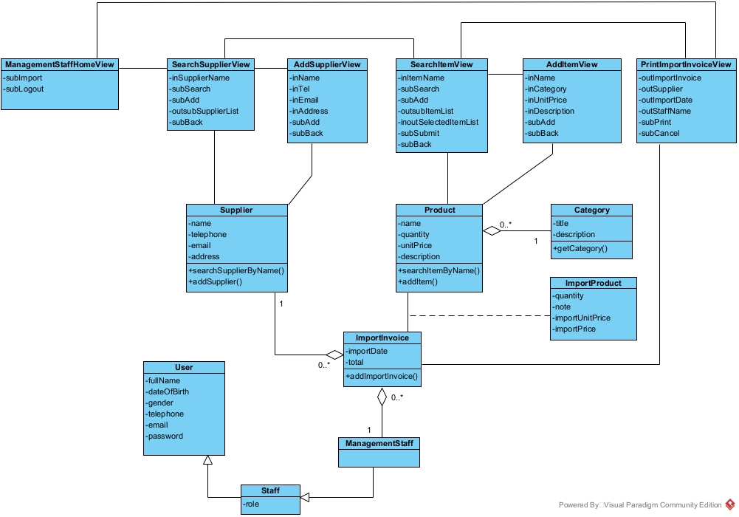

4. State diagram
- Register as a member module:
- At the Greeting UI, the system switches to Register UI when the register as a member function is selected
- At the Register UI, when the customer fills the form and selects the Add button, the system saves the new member data, returns to the Greeting UI and reaches the end.
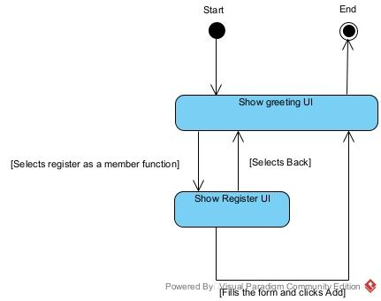
- Import goods module:
- At the Management staff home UI, the system switches to the Search supplier UI when the import function is selected.
- At the Search supplier UI, when the management staff enter the supplier name and click Search, the Search supplier UI will display the found supplier list.
- At the Search supplier UI, when the management staff selects a supplier and chooses Next, the system redirects to the Search item UI. If the management staff selects the add function, the system will switch to the Add supplier UI.
- At the Add supplier UI, the system will return to the Search supplier UI if the management staff fills out the new supplier information and selects add new supplier.

- At the Search item UI, when the management staff enter the item name and click Search, the Search item UI will display the found item list.
- At the Search item UI, when the management staff selects an item and updates item’s quantity, unit price, the Search item UI will add that item into the selected items table and update its import price
- At the Search item UI, when the management staff chooses Submit, the system redirects to the Print import invoice UI. If the management staff selects the add function, the system will switch to the Add item UI.
- At the Add item UI, the system will return to the Search item UI if the management staff fills out the new item information and selects add new item.
- At the Print import invoice UI, when the management staff clicks the Print button, the system will save the import invoice, return to the Management staff home UI and reach the end.
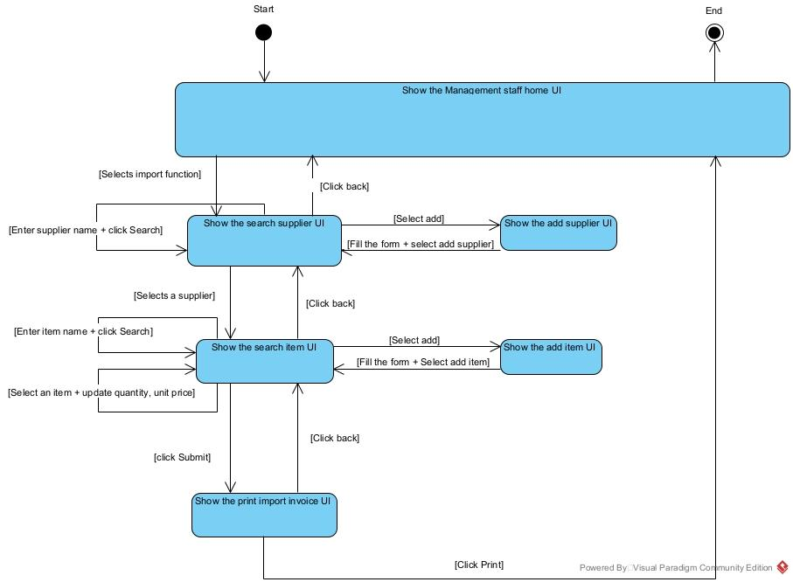

5. Communication diagram & sequence diagram
- Register as a member module:
* Scenario V2:
- At the Greeting UI, a customer clicks the Register button.
- The class GreetingView calls the class RegisterView.
- The class RegisterView displays itself to the customer.
- The customer enter all the following information: full name, date of birth, telephone number, email, gender, password and click Add button
- The RegisterView calls the class Customer
- The class Customer calls the method addCustomer()
- The class Customer returns to the class RegisterView
- The class RegisterView displays a success notification to the customer
- The customer clicks OK
- The class RegisterView calls the class GreetingView
- the class GreetingView displays itself to the customer

* Communication diagram:
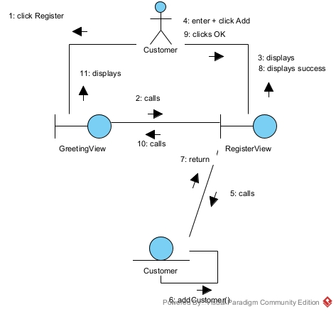
* Sequence diagram:
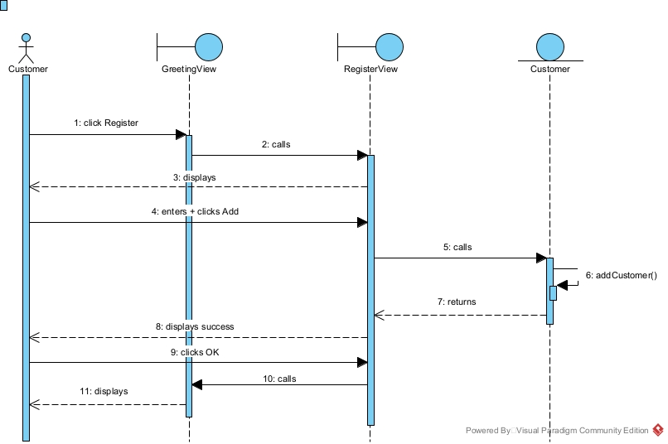

- Import goods module:
* Scenario V2:
- After login, at the ManagementStaffHomeView, the management staff selects the import menu
- The class ManagementStaffHomeView calls the class SearchSupplierView
- The class SearchSupplierView displays itself to the management staff
- The management staff asks the supplier for his/her name
- The supplier answers the name
- The management staff enter his/her name in the search text field + click Search
- The class SearchSupplierView calls the class Supplier
- The class Supplier calls the method searchSupplierByName() with the supplier name as the parameter
- The class Supplier returns the list of suppliers to the class SearchSupplierView
- The class SearchSupplierView displays the supplier list to the management staff
- The management staff select the correct supplier and click Next
- The class SearchSupplierView calls the class SearchItemView
- The class SearchItemView displays itself to the management staff
- The management staff asks the supplier for his/her item’s name
- The supplier answers the item’s name
- The management staff enter the name in the search text field + click Search
- The class SearchItemView calls the class Product
- The class Product calls the method searchItemByName() with the item name as the input
- The class Product returns the founded item list to the class SearchItemView
- The class SearchItemView displays the item list to the management staff
- The management staff select the correct item row in the list
- The SearchItemView add the selected item into the selected item table and displays it to the management staff
- The management staff asks the supplier for the import quantity and import unit price of that item
- The supplier gives both of that information
- The management staff updates the import quantity and import unit price of that item into the corresponding text fields
- The SearchItemView update the price of that item, the import total and displays it to the management staff
- The management staff clicks Submit button
- The SearchItemView calls the class PrintImportInvoiceView
- The PrintImportInvoiceView displays itself to the management staff
- The management staff click Print button
- The PrintImportInvoiceView calls the class ImportInvoice
- The class ImportInvoice calls the methods addImportInvoice()
- The class ImportInvoice returns the class PrintImportInvoiceView
- The class PrintImportInvoiceView displays a successful import message to the management staff
- The management staff clicks OK button on the message
- The SearchItemView calls the class ManagementStaffHomeView
- The class ManagementStaffHomeView displays itself to the management staff
- The management staff tells the supplier the completion of import goods process

* Communication diagram:
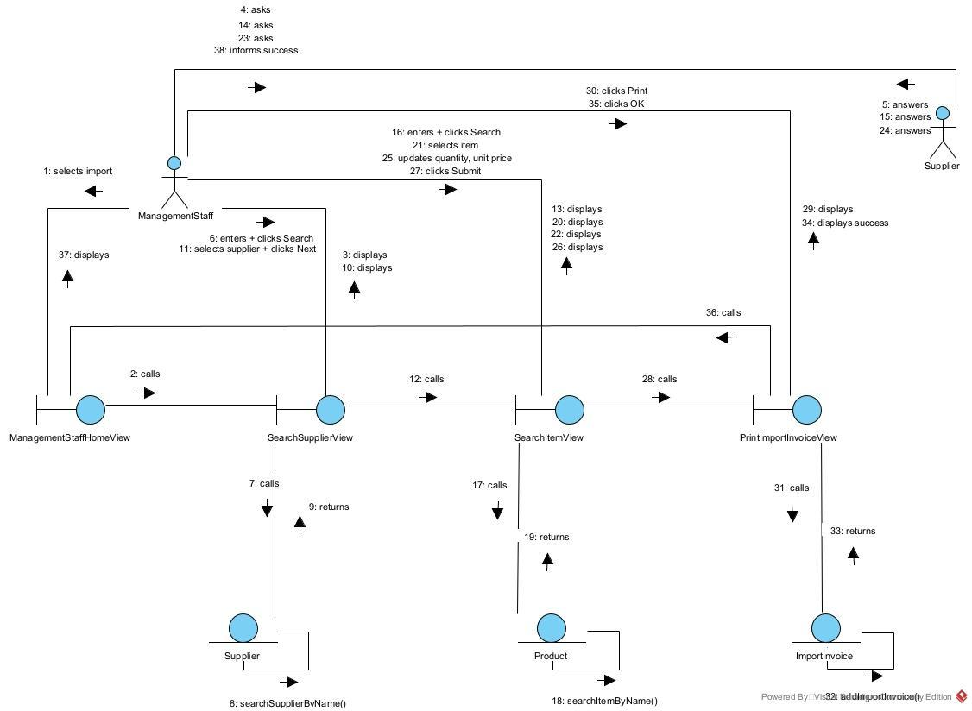

* Sequence diagram:
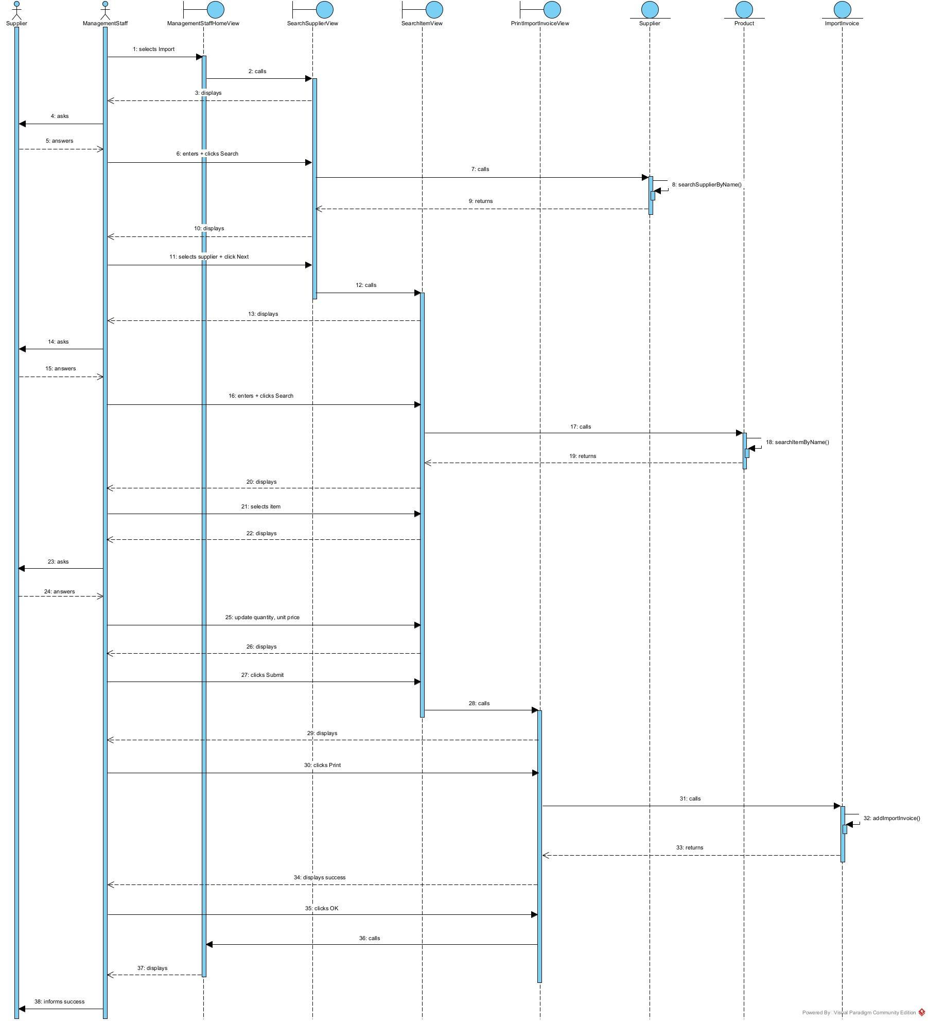

D. By design

1. Design of entity classes
- Step 1: ID attribute is added to all classes except of statistics classes, Staff class, SaleStaff class, Customer class, ManagementStaff class
- Step 2: Corresponding data types is added to All class’s attributes based on the Java programming language
- Step 3: Convert association relationship to aggregation/ composition
+ ImportInvoice – Product -> ImportProduct converts into: ImportProduct is a component of ImportInvoice, Product is a component of ImportProduct.
+ Invoice – Product -> ExportProduct converts into: ExportProduct is a component of Invoice, Product is a component of ExportProduct.
- Step 4: Add component attributes of all Aggregation/Composition relationships
+ Category is a component of Product, of type 1 – N → Product has a Category.
+ DeliveryStaff is a component of Invoice, of type 1 – N → Invoice has a DeliveryStaff.
+ SaleStaff is a component of Invoice, of type 1 – N → Invoice has a SaleStaff.
+ Customer is a component of Invoice, of type 1 – N → Invoice has a Customer.
+ ExportProduct is a component of Invoice, of type N – 1 → Invoice has a list of ExportProduct.
+ Supplier is a component of ImportInvoice, of type 1 – N → ImportInvoice has a Supplier.
+ ManagementStaff is a component of ImportInvoice, of type 1 – N → ImportInvoice has a ManagementStaff.
+ ImportProduct is a component of ImportInvoice, of type N – 1 → ImportInvoice has a list of ImportProduct.

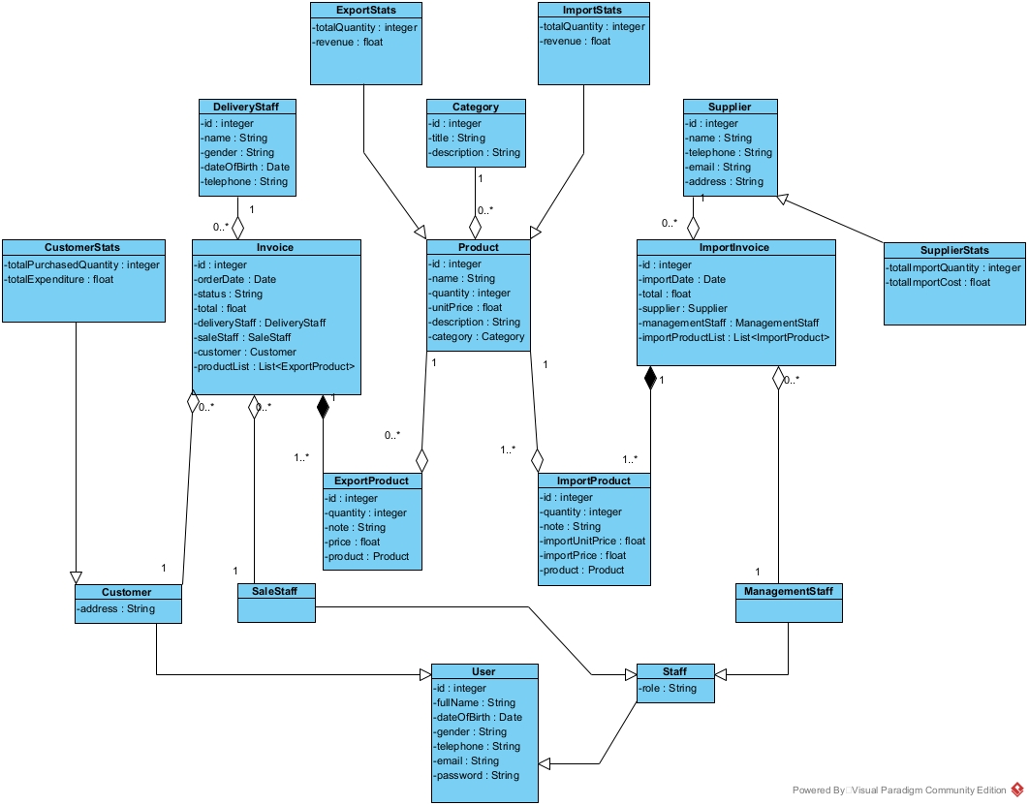

2. Database design
- Step 1: Each entity class suggest a corresponding table
+ Class User -> table tblUser
+ Class Staff -> table tblStaff
+ Class ManagementStaff -> table tblManagementStaff
+ Class SaleStaff -> table tblSaleStaff
+ Class Customer -> table tblCustomer
+ Class Product -> table tblProduct
+ Class ImportProduct -> table tblImportProduct
+ Class ExportProduct -> table tblExportProduct
+ Class Invoice -> table tblInvoice
+ Class ImportInvoice -> table tblImportInvoice
+ Class Category -> table tblCategory
+ Class Supplier -> table tblSupplier
+ Class DeliveryStaff -> table tblDeliveryStaff
+ Class ImportStats -> table tblImportStats
+ Class ExportStats -> table tblExportStats
+ Class CustomerStats -> table tblCustomerStats
+ Class SupplierStats -> table tblSupplierStats

- Step 2: convert attributes (not an object of an entity) of each entity to attributes of its corresponding table
+ tblUser: id, fullName, dateOfBirth, gender, telephone, email, password
+ tblStaff: role
+ tblManagementStaff:
+ tblSaleStaff:
+ tblCustomer: address
+ tblProduct: id, name, quantity, unitPrice, description
+ tblImportProduct: id, quantity, importUnitPrice, note
+ tblExportProduct: id, quantity, note
+ tblInvoice: id, orderDate, status
+ tblImportInvoice: id, importDate
+ tblCategory: id, title, description
+ tblDeliveryStaff: id, name, gender, dateOfBirth, telephone
+ tblSupplier: id, name, telephone, email, address
+ tblImportStats: totalQuantity, totalRevenue
+ tblExportStats: totalQuantity, totalRevenue
+ tblCustomerStats: totalPurchasedQuantity, totalExpenditure
+ tblSupplierStats: totalImportQuantity, totalImportCost

- Step 3: convert numerical relationships between entity classes into numerical relationships between tables
+ 1 tblUser - 1 tblStaff
+ 1 tblStaff - 1 tblManagementStaff
+ 1 tblStaff - 1 tblSaleStaff
+ 1 tblUser - 1 tblCustomer
+ 1 tblProduct - n tblImportProduct
+ 1 tblProduct - n tblExportProduct
+ 1 tblInvoice - n tblExportProduct
+ 1 tblImportInvoice - n tblImportProduct
+ 1 tblSupplier - n tblImportInvoice
+ 1 tblManagementStaff - n tblImportInvoice
+ 1 tblDeliveryStaff - n tblInvoice
+ 1 tblSaleStaff - n tblInvoice
+ 1 tblCustomer - n tblInvoice
+ 1 tblCategory - n tblProduct
+ 1 tblProduct – 1 tblImportStats
+ 1 tblProduct – 1 tblExportStats
+ 1 tblCustomer – 1 tblCustomerStats
+ 1 tblSupplier – 1 tblSupplierStats

- Step 4: Add keys for each table. Primary key is set based on the id of each corresponding table, except: tblStaff, tblCustomer, tblManagementStaff, tblSaleStaff
* Set up foreign keys for tables:
+ 1 tblUser - 1 tblStaff -> tblStaff has a foreign key: tblUserid which is also a primary key
+ 1 tblStaff - 1 tblManagementStaff -> tblManagementStaff has a foreign key: tblUserid which is also a primary key
+ 1 tblStaff - 1 tblSaleStaff -> tblSaleStaff has a foreign key: tblUserid which is also a primary key
+ 1 tblUser - 1 tblCustomer -> tblCustomer has a foreign key: tblUserid which is also a primary key
+ 1 tblProduct - n tblImportProduct -> tblImportProduct has a foreign key: tblProductid
+ 1 tblProduct - n tblExportProduct -> tblExportProduct has a foreign key: tblProductid
+ 1 tblInvoice - n tblExportProduct -> tblExportProduct has a foreign key: tblInvoiceid
+ 1 tblImportInvoice - n tblImportProduct -> tblImportProduct has a foreign key: tblImportInvoiceid
+ 1 tblSupplier - n tblImportInvoice -> tblImportInvoice has a foreign key: tblSupplierid
+ 1 tblManagementStaff - n tblImportInvoice -> tblImportInvoice has a foreign key: tblManagementStaffid
+ 1 tblDeliveryStaff - n tblInvoice -> tblInvoice has a foreign key: tblDeliveryStaffid
+ 1 tblSaleStaff - n tblInvoice -> tblInvoice has a foreign key: tblSaleStaffid
+ 1 tblCustomer - n tblInvoice -> tblInvoice has a foreign key: tblCustomerid
+ 1 tblCategory - n tblProduct -> tblProduct has a foreign key: tblCategoryid

- Step 5: Eliminate redundancy attributes
* Duplicate:
There is no duplicate attribute.
* Secondary:
+ tblImportStats, tblExportStats, tblCustomerStats, tblSupplierStats because they are statistic tables
+ total from tblInvoice because it could be calculated from tbl_ExportProduct
+ total from tblImportInvoice because it could be calculated from tbl_ImportProduct
+ importPrice from tblImportProduct because it could be calculated from a formula: quantity x importUnitPrice
+ price from tblExportProduct because it could be calculated from a formula: quantity x unitPrice (from tblProduct)

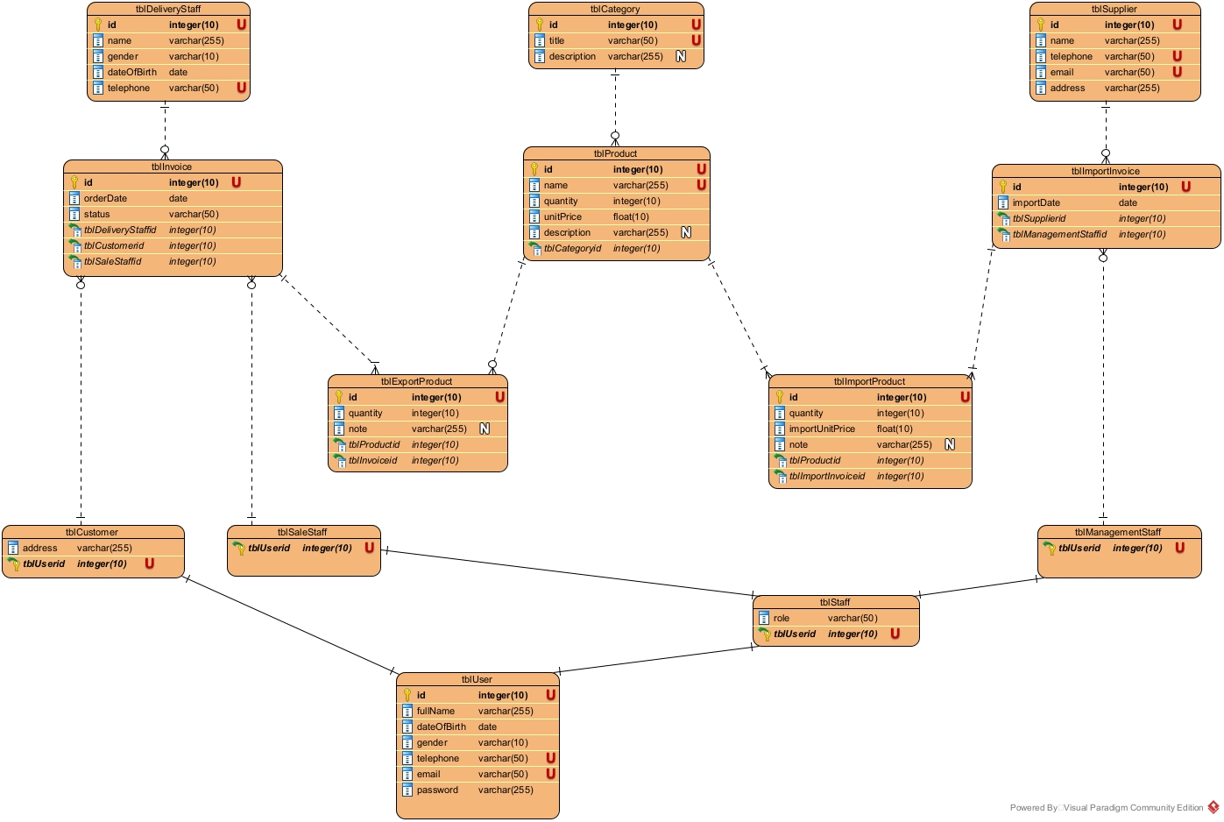

3. Detail design for modules
3.1. Static design
a. Module register as a member
- Interface layer consists of jsp classes: GreetingView, RegisterView
- Controller layer consist of controller class: CustomerController
- Data manipulation layer consist of DAO class: CustomerDAO
- Entity layer consists of all related entity classes: User, Customer

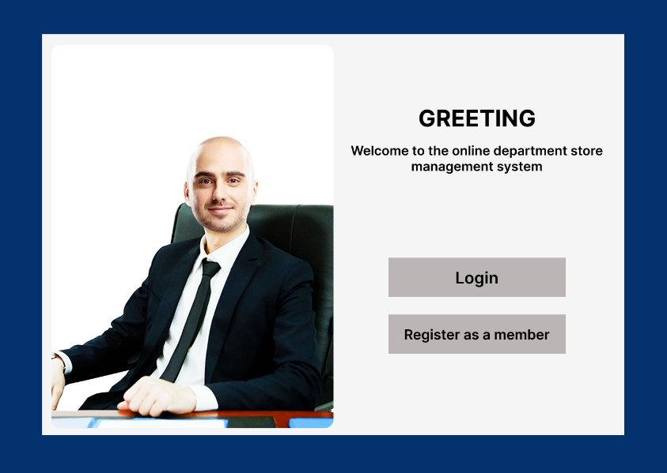

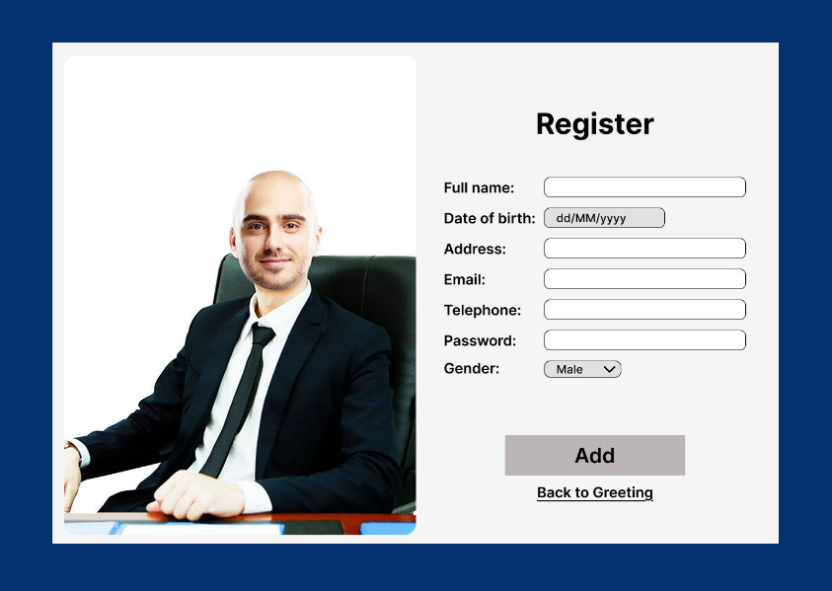
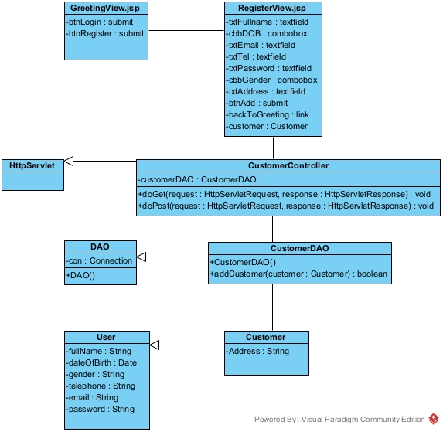
b. Module import goods
- Interface layer consists of jsp classes: ManagementStaffHomeView, SearchSupplierView, AddSupplierView, SearchItemView, AddItemView, PrintImportInvoiceView
- Controller layer consist of controller classes: SupplierController, ProductController, ImportInvoiceController, CategoryController
- Data manipulation layer consist of DAO classes: SupplierDAO, ProductDAO, ImportInvoiceDAO, CategoryDAO
- Entity layer consists of all related entity classes: User, Staff, ManagementStaff, Supplier, Product, ImportProduct, ImportInvoice, Category
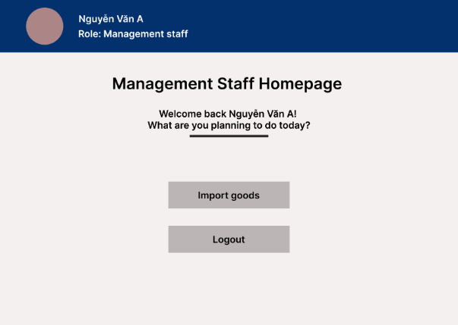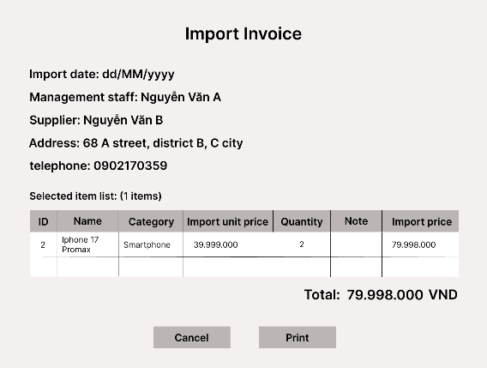

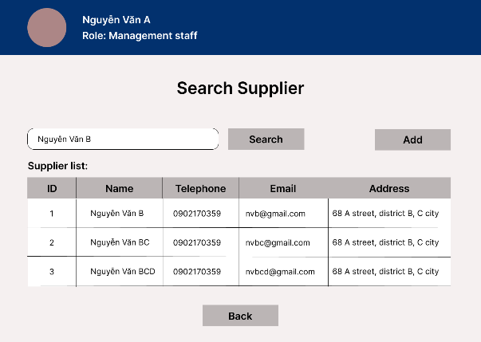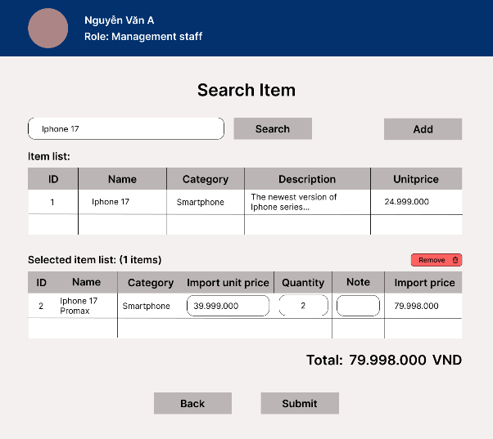

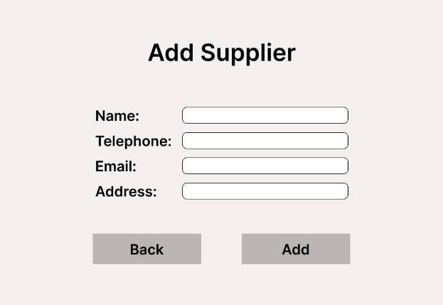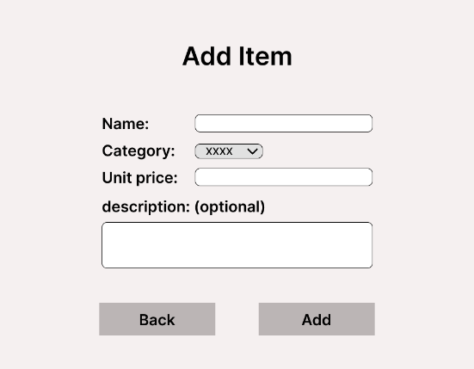

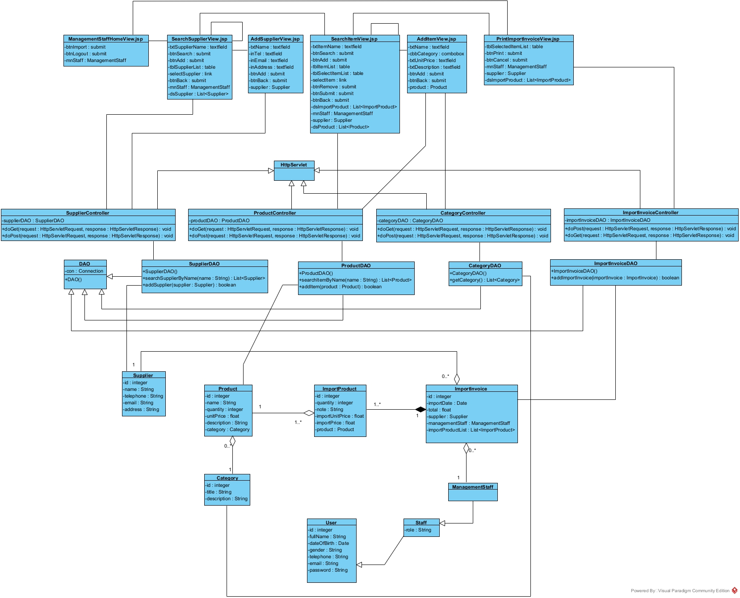

3.2. Dynamic design
a. Register as a member
* Activities diagram

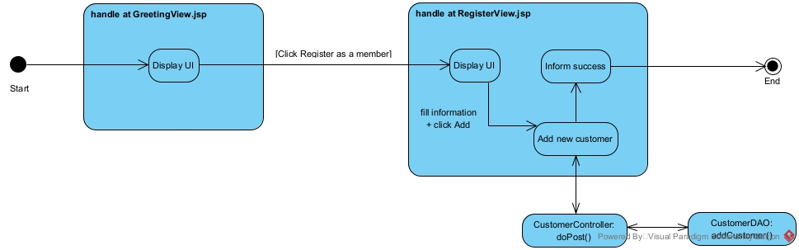
* Scenarios v3
- From the GreetingView.jsp, the customer selects the Register button.
- The GreetingView.jsp calls the RegisterView.jsp
- The RegisterView.jsp displays to the customer
- The customer enters all his/her information and clicks Add
- The RegisterView.jsp calls the class CustomerController
- The class CustomerController calls the method doPost()
- The method doPost() calls the class Customer to packs its information
- The class Customer packs its information
- The class Customer returns the result to the method doPost()
- The method doPost() calls the class CustomerDAO to add a new customer into the system
- The CustomerDAO calls the methods addCustomer()
- The method addCustomer() returns to the method doPost()
- The method doPost() returns to the RegisterView.jsp
- The RegisterView.jsp displays a pop-up success notification to the customer
- The customer clicks OK
- The RegisterView.jsp calls the GreetingView.jsp
- The GreetingView.jsp displays to the customer

* Sequence diagram v2
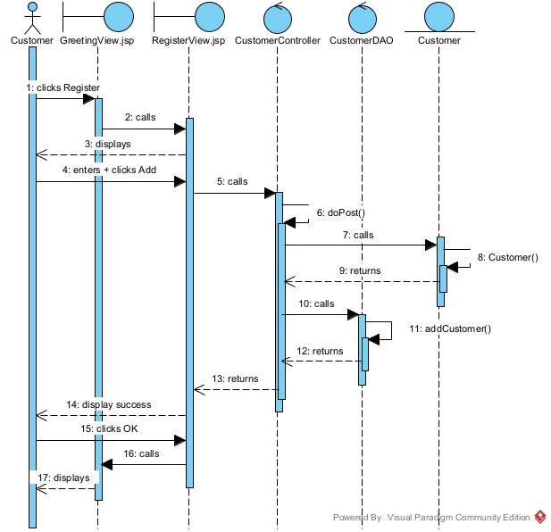
b. Import goods
* Activities diagram

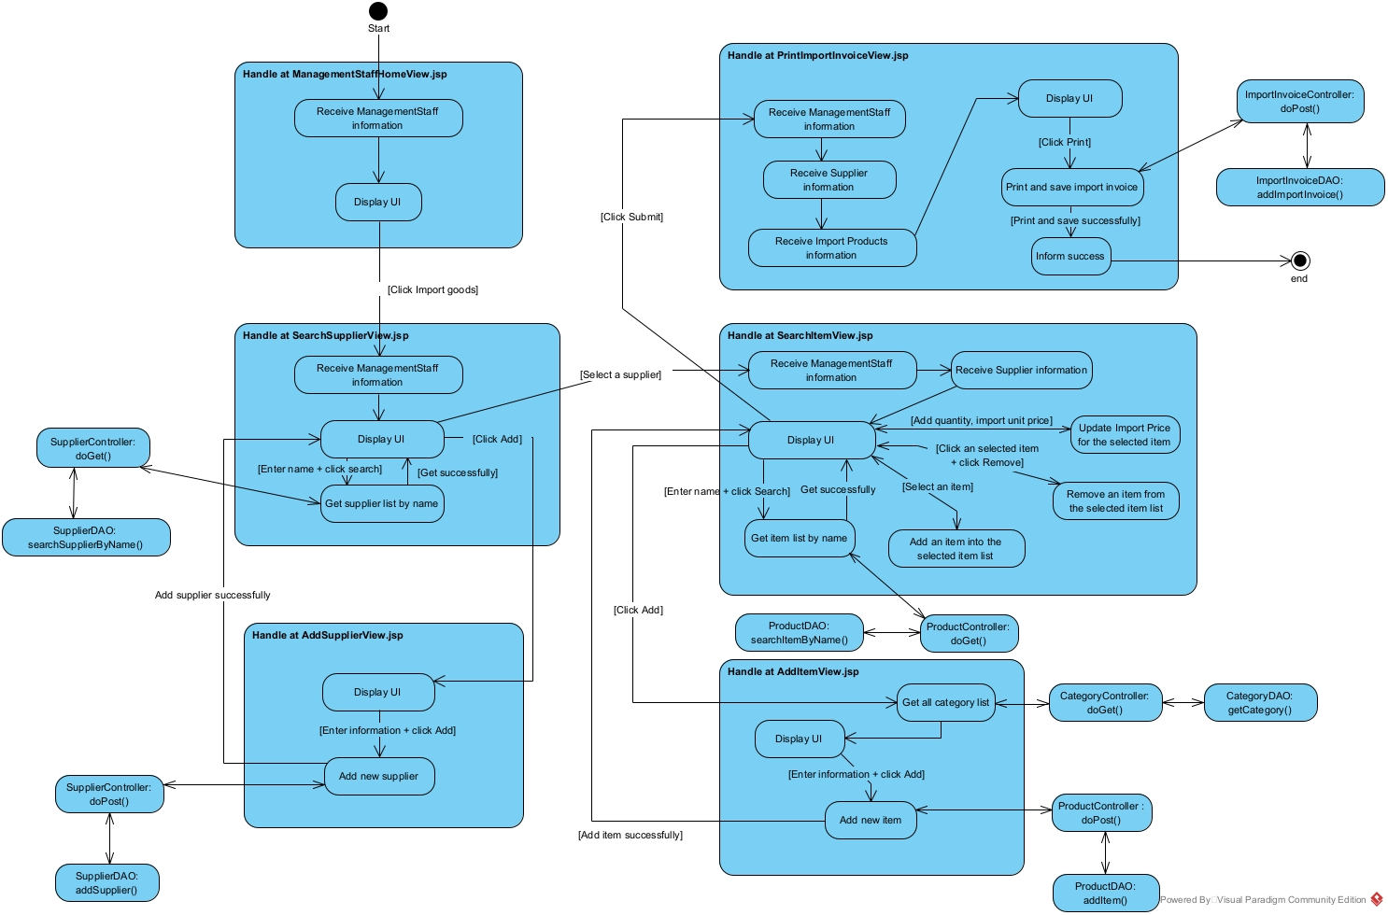

* Scenarios v3
- After login, from the ManagementStaffHomeView.jsp, the management staff clicks the Import goods button
- The ManagementStaffHomeView.jsp calls the SearchSupplierView.jsp
- The SearchSupplierView.jsp displays to the management staff
- The management staff asks the supplier for his/her name
- The supplier answers
- The management staff enters the name + clicks Search
- The SearchSupplierView.jsp calls the class SupplierController
- The class SupplierController calls the method doGet()
- The method doGet() calls the class supplierDAO
- The class SupplierDAO calls the method searchSupplierByName()
- The method searchSupplierByName() calls the class Supplier to packs its information
- The Supplier packs its information
- The Supplier returns the result to the method searchSupplierByName()
- The method searchSupplierByName() returns the result to the method doGet()
- The method doGet() returns the result to the SearchSupplierView.jsp
- The SearchSupplierView.jsp displays to the management staff
- The management staff selects the correct supplier
- The SearchSupplierView.jsp calls the class SupplierController
- The class SupplierController calls the method doPost()
- The method doPost() calls the class Supplier to packs its information
- The class Supplier packs its information
- The class Supplier returns the result to the method doPost()
- The method doPost() calls the SearchItemView.jsp
- The SearchItemView.jsp displays itself to the management staff
- The management staff asks the supplier the name of the item
- The supplier answers
- The management staff enter the item name and click Search
- The SearchItemView.jsp calls the class ProductController
- The class ProductController calls the method doGet()
- The method doGet() calls the class ProductDAO()
- The class ProductDAO calls the method searchItemByName()
- The method searchItemByName() calls the class Product to pack its information
- The class Product packs its information
- The class Product calls the class Category to pack its information
- The class Category packs its information
- The class Category returns the result to the class Product
- The class Product returns the result to the method searchItemByName()
- The searchItemByName() returns the result to the method doGet()
- The method doGet() returns the result to the SearchItemView.jsp
- The SearchItemView.jsp displays to the management staff
- The management staff selects the correct item
- The SearchItemView.jsp calls the class ProductController
- The class ProductController calls the method doPost()
- The method doPost() calls the class ImportProduct to pack its information
- The class ImportProduct packs its information
- The class ImportProduct returns the result to the method doPost()
- The method doPost() returns the result to the the SearchItemView.jsp
- The SearchItemView.jsp displays the selected item to the management staff
- The management staff asks the supplier the item’s quantity and import unit price
- The supplier answers
- The management staff add quantity and import unit price to the selected item
- The SearchItemView.jsp calls the class ProductController
- The class ProductController calls the method doPost()
- The method doPost() calls the class ImportProduct to update its import quantity and import unit price
- The class ImportProduct calls the method setter()
- The class ImportProduct returns the result to the method doPost()
- The method doPost() returns the result to the SearchItemView.jsp
- The SearchItemView.jsp displays the updates to the management staff
(repeat from step 25 to 58 until all the import goods are finished)
- The management staff clicks Submit
- The SearchItemView.jsp calls the PrintImportInvoiceView.jsp
- The PrintImportInvoiceView.jsp displays itself to the management staff
- The management staff clicks the Print button
- The PrintImportInvoiceView.jsp calls the class ImportInvoiceController
- The class ImportInvoiceController calls the method doPost()
- The method doPost() calls the class ImportInvoice to packs its information
- The class ImportInvoice packs its information
- The class ImportInvoice returns the result to the method doPost()
- The method doPost() calls the class ImportInvoiceDAO to save the import invoice into the system
- The ImportInvoiceDAO calls the method addImportInvoice()
- The method addImportInvoice() returns the result to the method doPost()
- The method doPost() returns the result to the PrintImportInvoiceView.jsp
- The PrintImportInvoiceView.jsp displays a pop-up success notification to the management staff
- The management staff clicks OK
- The PrintImportInvoiceView.jsp calls the ManagementStaffHomeView.jsp
- ManagementStaffHomeView.jsp displays itself to the management staff.
- The management staff informs the completion of import goods to the supplier
* Sequence diagram v2
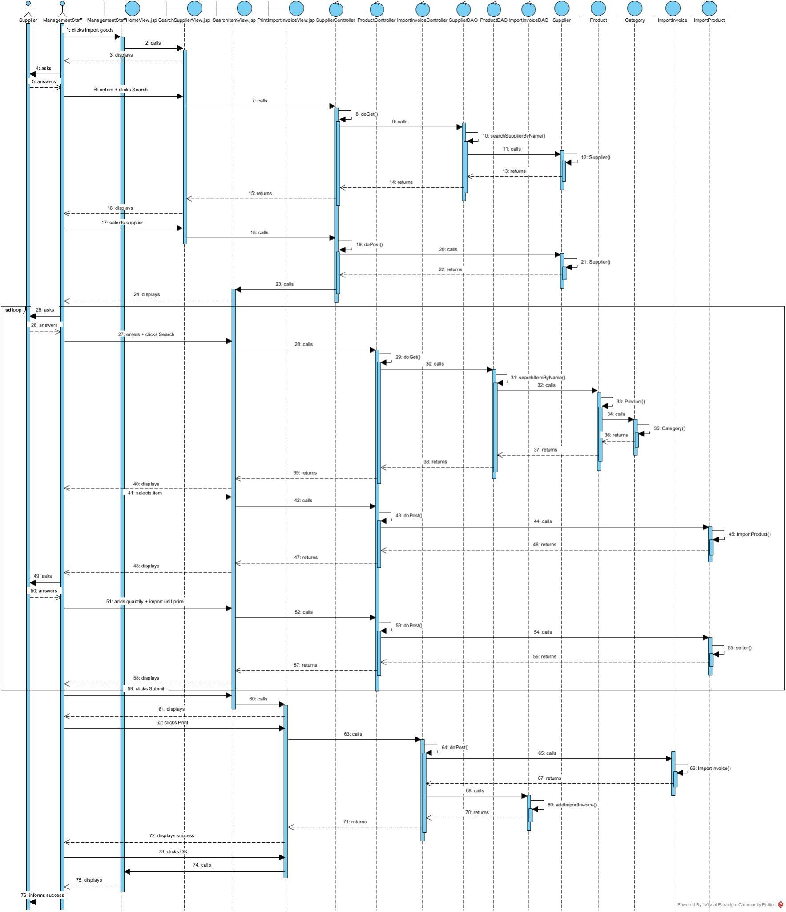

4. Deployment design
* Package diagram:
- Entity classes are located in model package
- Controller classes are located in controller package
- DAO classes are located in dao package
- jsp pages are located in view package. View package is divided into small packages corresponding to interface of different user groups
+ jsp pages handle login and greeting are placed in user package
+ jsp pages handle customer’s services are placed in customer package
+ jsp pages handle sale staff’s services are placed in saleStaff package
+ jsp pages handle management staff’s services are placed in managementStaff package

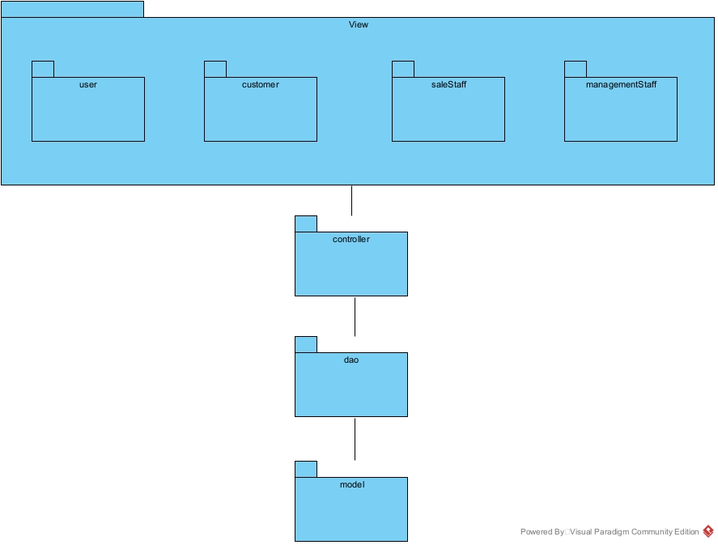
* Deployment diagram:
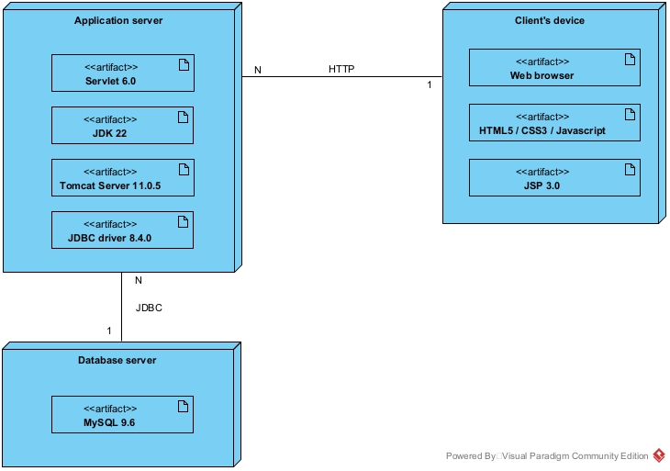

E. By programming

1. UI
a. Module register as a member
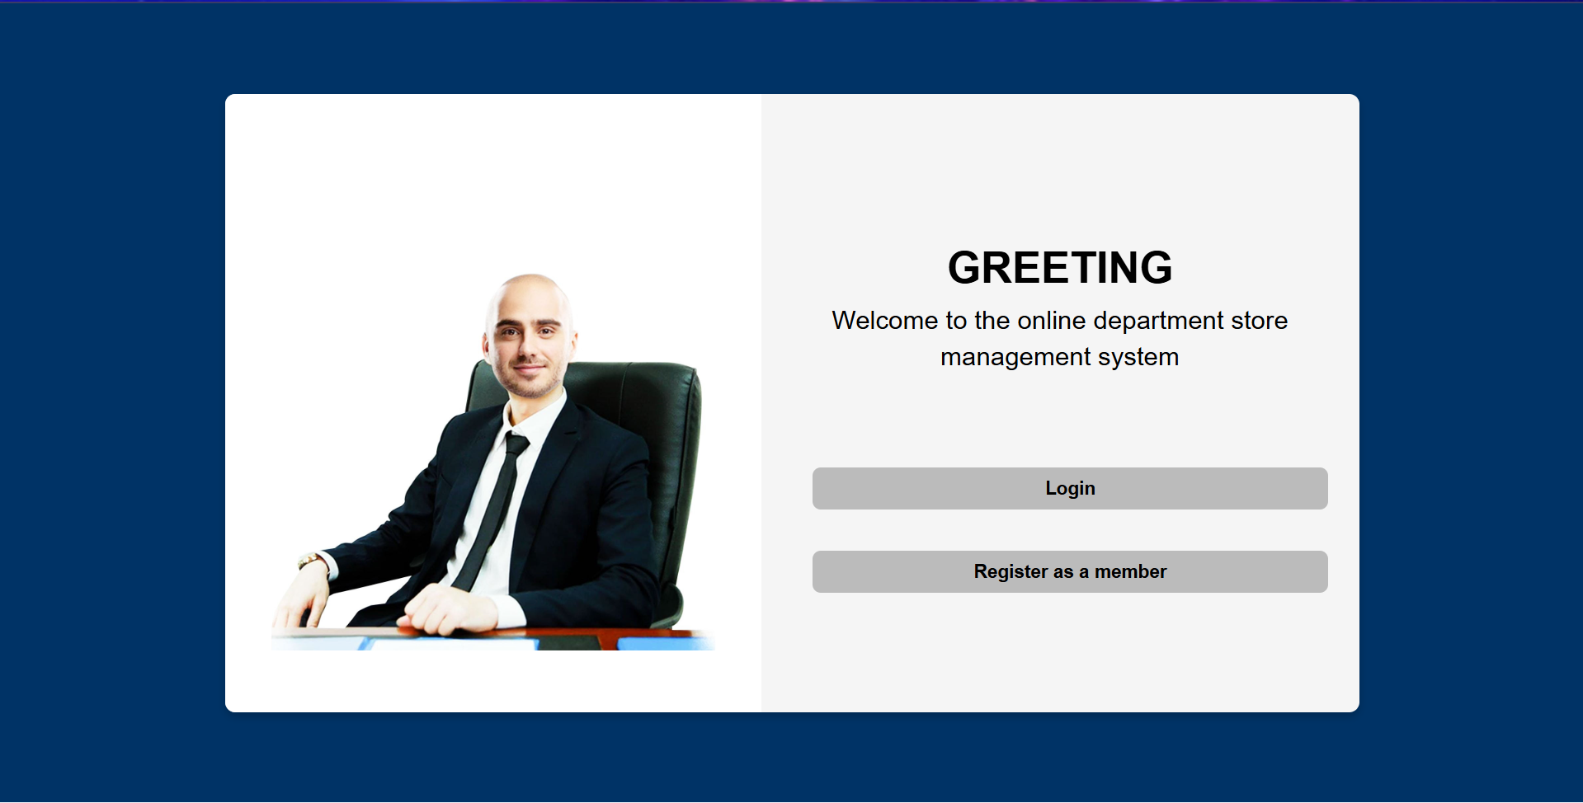
Page GreetingView.jsp
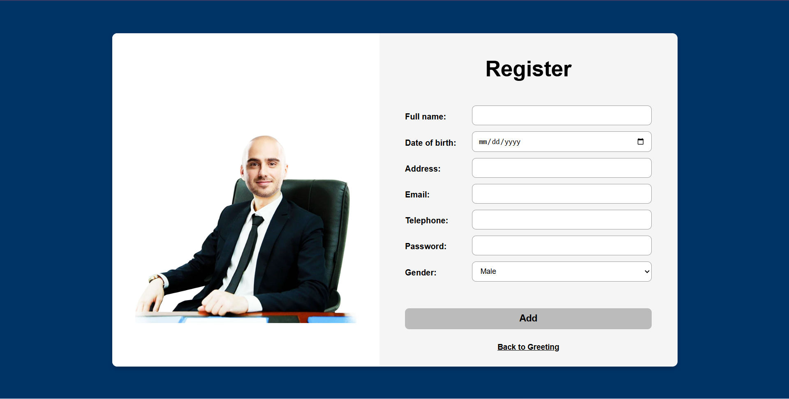
Page RegisterView.jsp

b. Module import goods


Page GreetingView.jsp
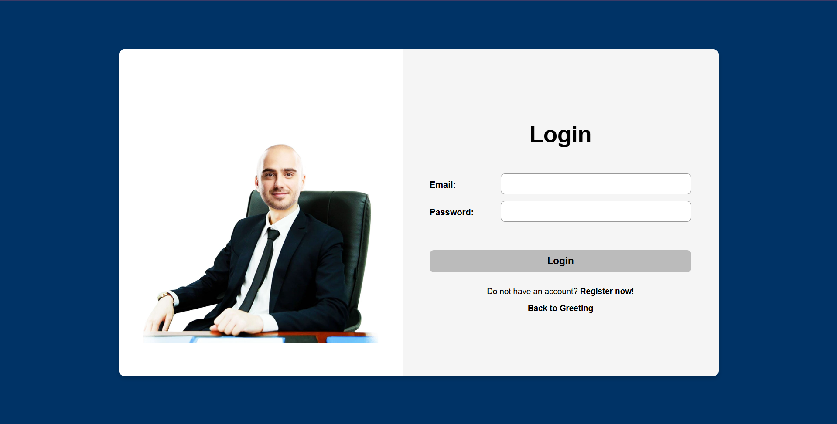
Page LoginView.jsp

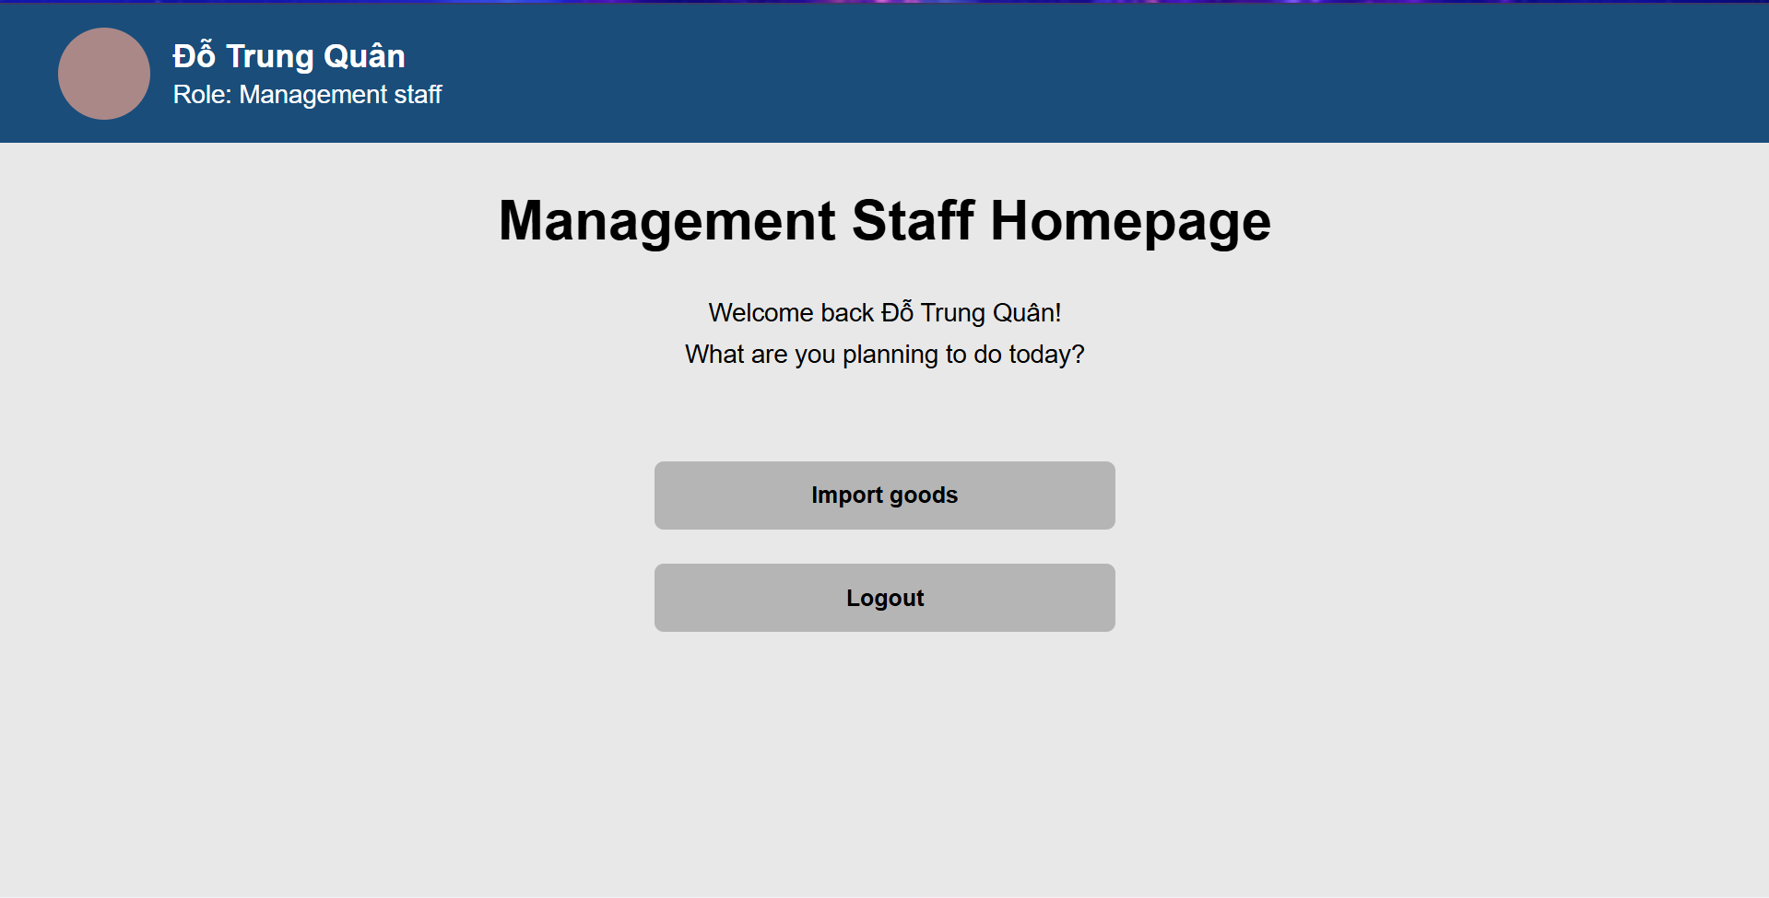
Page ManagementStaffHomeView.jsp
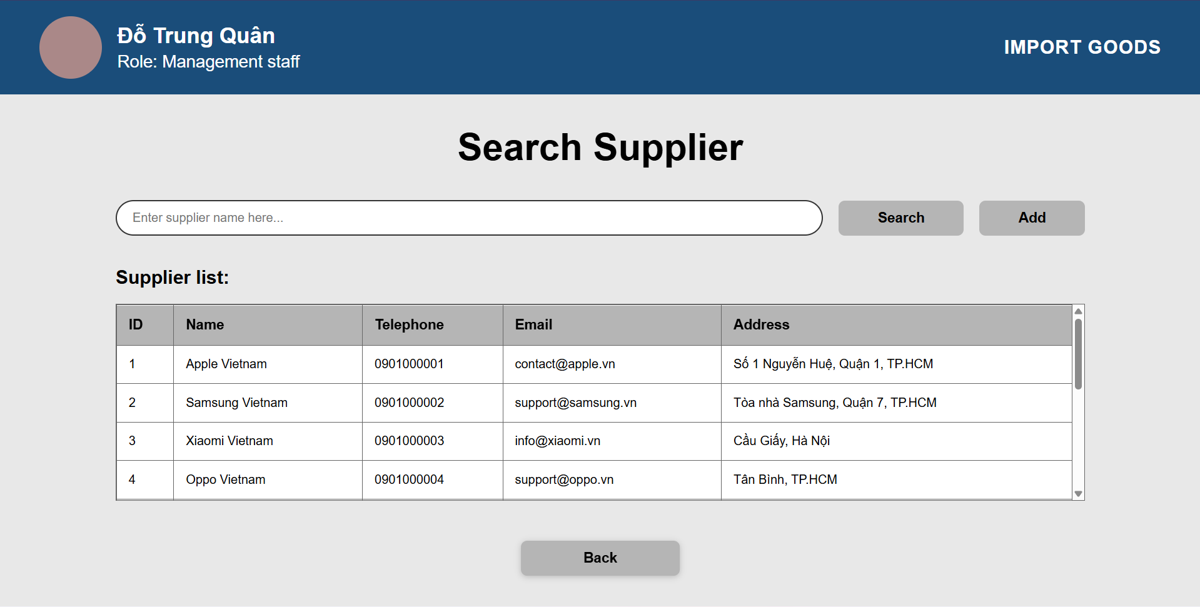
Page SearchSupplierView.jsp

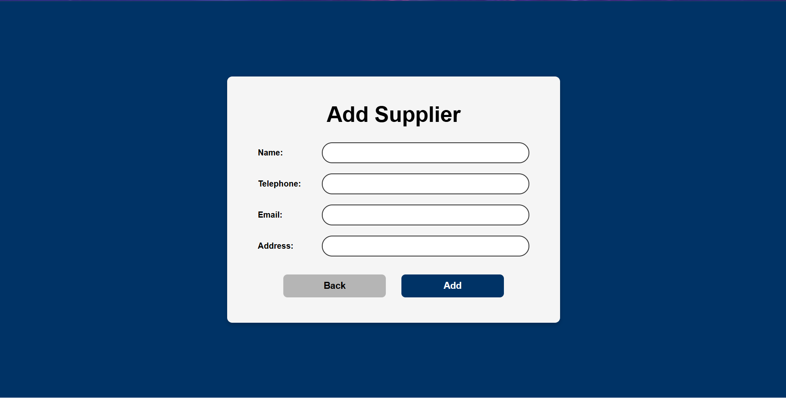
Page AddSupplierView.jsp
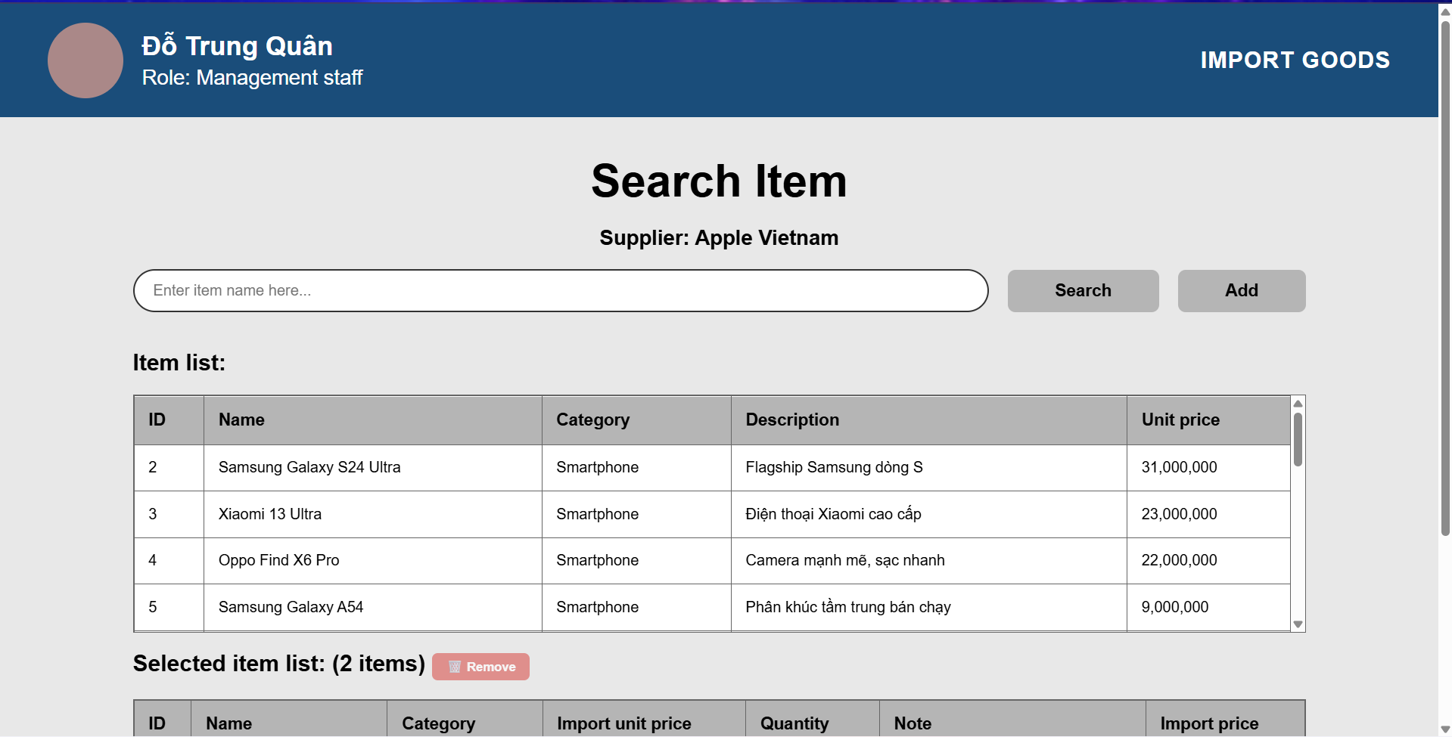
Page SearchItemView.jsp (1)

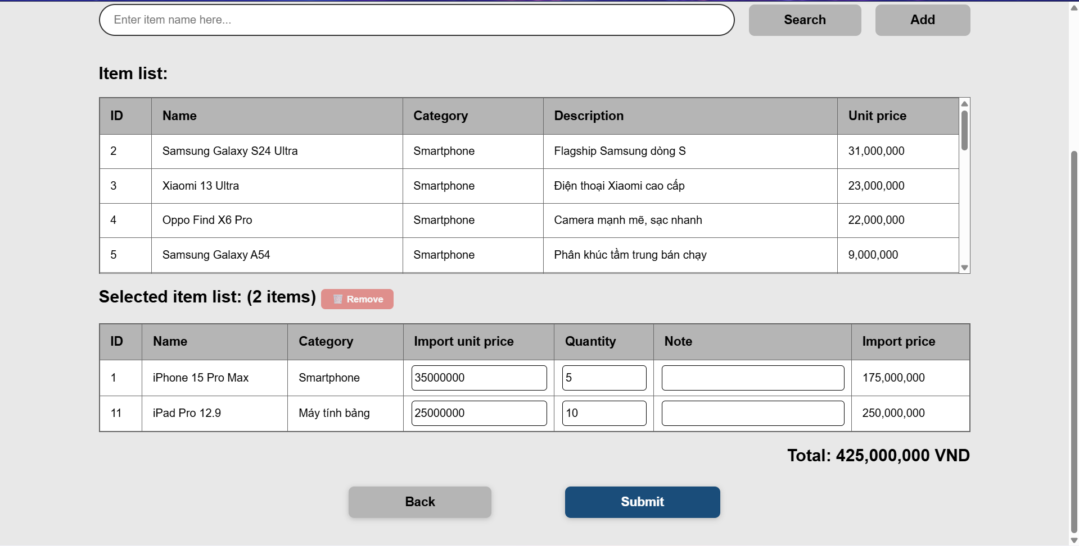
Page SearchItemView.jsp (2)

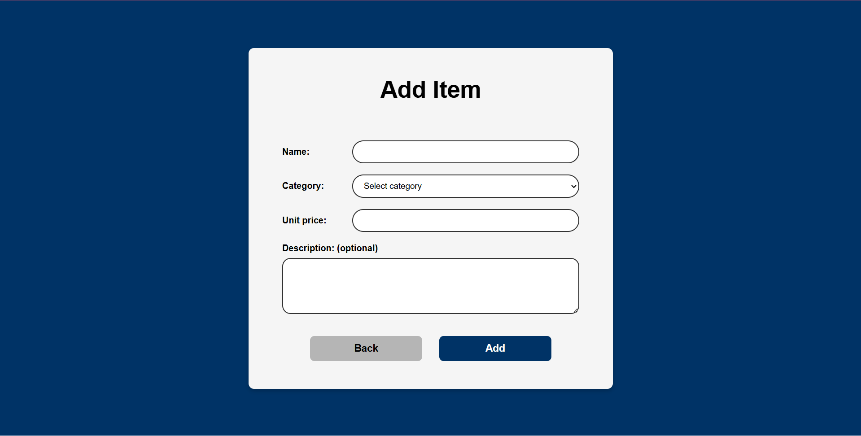
Page AddItemView.jsp

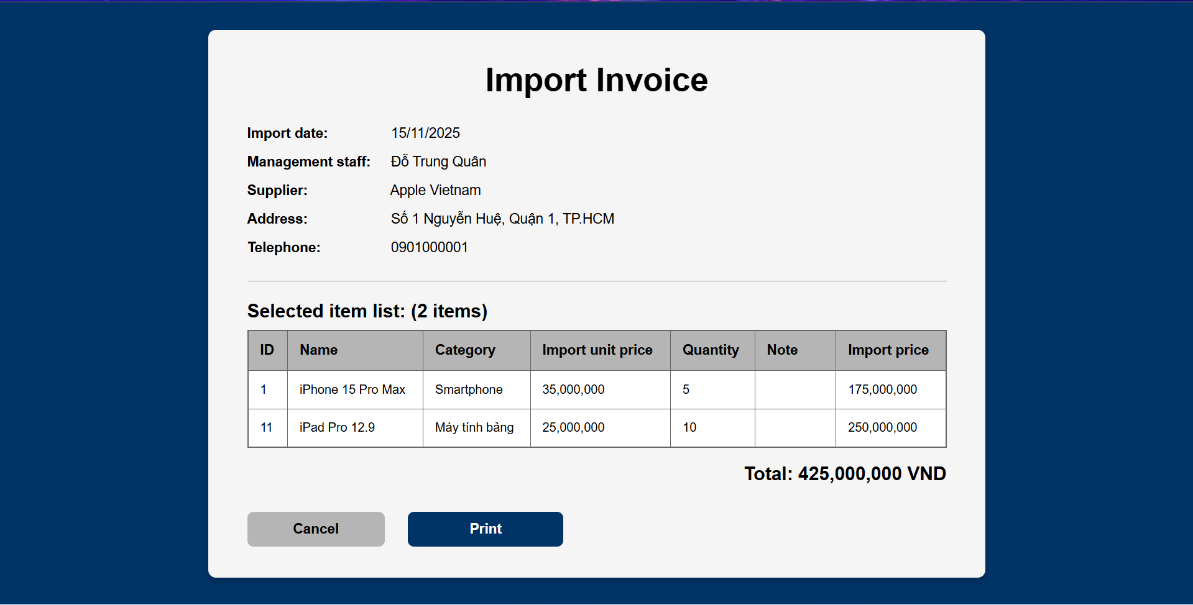
Page PrintImportInvoiceView.jsp

2. Files structure
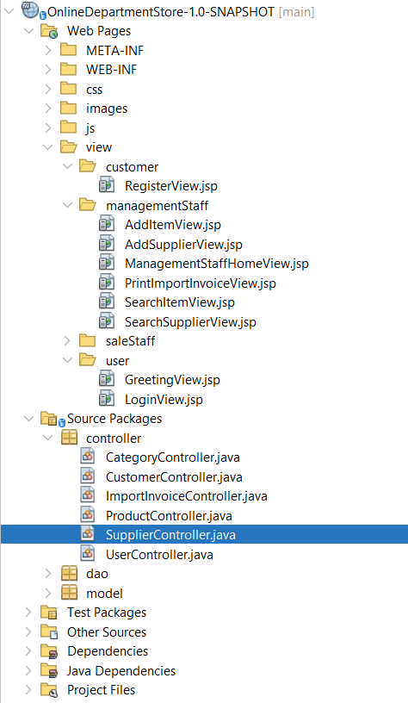

3. Source code
Link source code Github

